PRACTICE 5
- Write a query for the HR department to produce the addresses of all the departments. Use the LOCATIONS and COUNTRIES tables. Show the location ID, street address, city, state or province, and country in the output. Use a NATURAL JOIN to produce the results.

>> select location_id,street_address,city,state_province,country_name
From locations natural join countries;
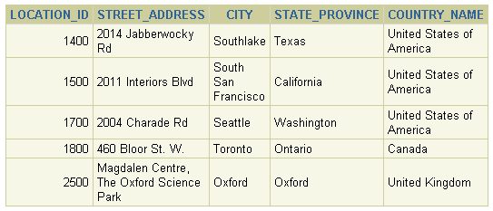
- The HR department needs a report of all employees. Write a query to display the last name, department number, and department name for all employees.

>> select last_name,department_id,department_name
From employees natural join departments;

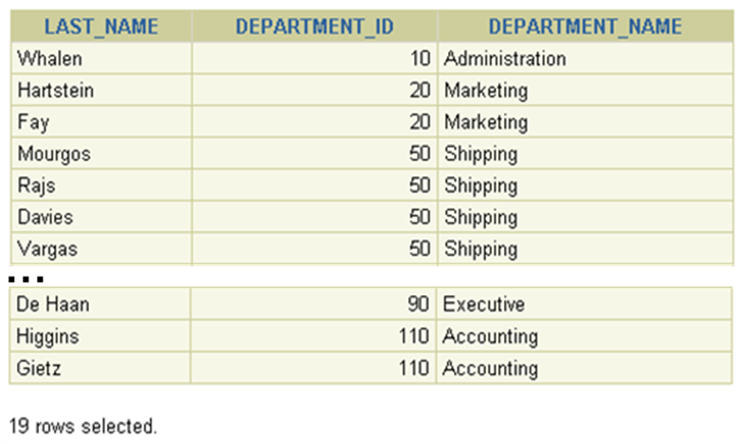
- The HR department needs a report of employees in Toronto. Display the last name, job, department number, and department name for all employees who work in Toronto.
>> select last_name,job_id,department_id,department_name
From employees e join departments d
On d.departments_id=e.department_id
Join locations l
On d.locations_id=l.locations_id; 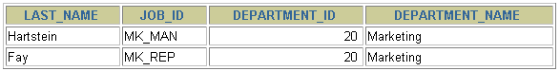
- Create a report to display employees’ last name and employee number along with their manager’s last name and manager number. Label the columns Employee, Emp#, Manager, and Mgr#, respectively.
>>select last_name Employee, employee_id EMP#, manager_last_name manager, manager_id Mgr#
From employees;
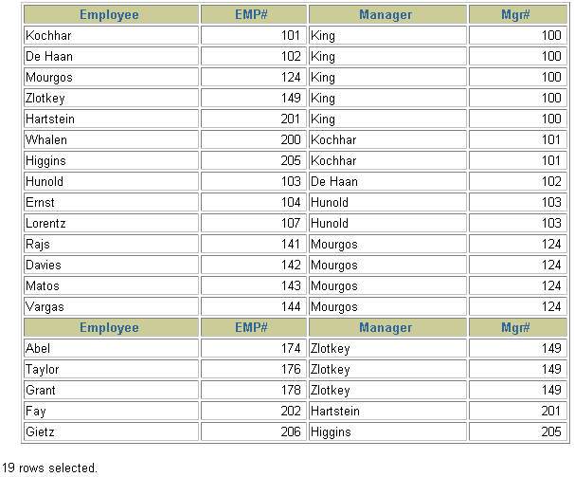
Practice 5 (continued)
- Modify lab_05 to display all employees including King, who has no manager. Order the results by the employee number.
>> select e.last_name Employee, e.employee_id EMP#, m.last_name Manager,m.manager_id Mgr#
From employees e join employees m
On (e.manager_id=m.employee_id);
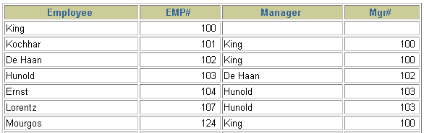
- Create a report for the HR department that displays employee last names, department numbers, and all the employees who work in the same department as a given employee. Give each column an appropriate label.
>> select department_id DEPARTMENT, last_name EMPLOYEE
From employees
Cross join departments;
